42

Summer Program Schedule
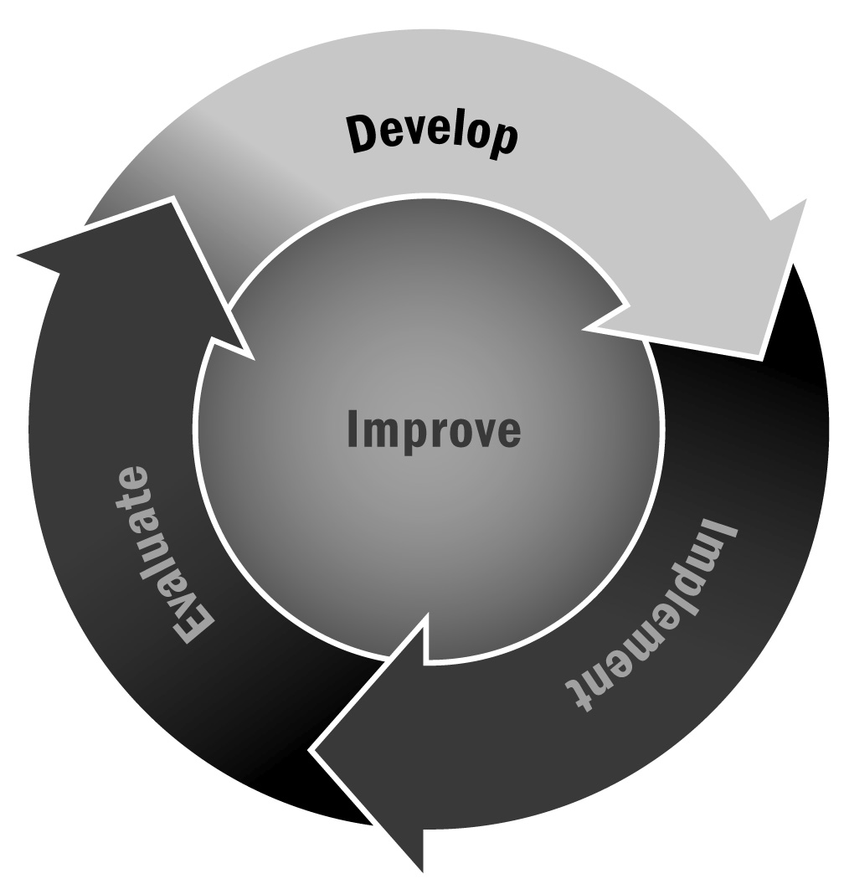
In Chapters 1 and 2, you learned that everyone benefits from having a well-defined schedule. This ensures that both the staff and stakeholders (i.e., youth, families, partners, and community members) know what to expect.
Directions: Use or adapt this tool to schedule and keep track of all program offerings that occur during summer programming. Be sure to include days offered, time, location, staffing, and other relevant information. A sample schedule is provided to get you started. Use the blank form at the end of this tool for your program.

Summer Science Camp
Week 1 – Theme “Bugs Gone Wild”
 | Time | Activity | Location | Staff
Monday | 8:00–8:30 | Breakfast/check-in | Cafeteria | John Smith, Ann Moore, community college volunteers
 | 8:30–8:45 | Transition time |  | All staff members oversee
 | 8:45–11:45 | Group 1  Group 2  Group 3  Group 4  Group 5 | Park  Park  Rm. 2b  Rm. 3  Rm. 5 | Audubon Society staff  Smith Hill Park Zoo staff  Jennifer Johnson and Mark Smith  Joe Jennings and Lydia Farmer  Adrian Foster and Jenna Ryan
 | 11:45–12:00 | Transition to lunch |  | All staff members oversee
 | 12:00–12:30 | Lunch | Cafeteria | All staff members oversee—program staff members sit with youth in groups
 | 12:30–12:45 | Transition time |  | All staff members oversee
 | 12:45–2:00 | Activity Choice 1  Yoga  Hip-hop  Theater  Clay studio  Baseball | 2b  5  Auditorium  Art room  Field | Jennifer Sloan  DJ Dance staff  Sophia Carter  Arts for All staff  Jeremiah Singer and Jose Lopez
 | 2:00–3:15 | Activity Choice 2 | All rooms stay same | Same instructors
 | 3:15–3:30 | Dismissal | Cafeteria | All staff members oversee
Tuesday | 8:00–8:30 | Breakfast/check-in | Cafeteria | John Smith, Ann Moore, community college volunteers
 | 8:30–8:45 | Transition time |  | All staff members oversee
 | 8:45–11:45 | Group 1  Group 2  Group 3  Group 4  Group 5 | 2b  3  Park  Park  Park | Jennifer Johnson and Mark Smith  Joe Jennings and Lydia Farmer  Audubon Society Staff  Audubon Society Staff  Smith Hill Park Zoo Staff
 | 11:45–12:00 | Transition to lunch |  | All staff members oversee
 | 12:00–12:30 | Lunch | Cafeteria | All staff members oversee—program staff members sit with youth in groups
 | 12:30–12:45 | Transition time |  | All staff members oversee
 | 12:45–2:00 | Activity Choice 1  Beat-making  Girls, Inc.  Chorus  Puppet making  Soccer | 2b  5  Auditorium  Art room  Field | Julie Firestone  Sasha Jones  Lawrence Fletcher  Arts for All staff  Jeremiah Singer and Jose Lopez
 | 2:00–3:15 | Activity Choice 2 | All rooms stay same | Same instructors
 | 3:15–3:30 | Dismissal | Cafeteria | All staff members oversee
Wednesday | Same as Monday schedule
Thursday | Same as Tuesday schedule
Friday | Field Trip—Potters Beach Day!

[Program Name]
[Program Session (Dates) – # Weeks]
 | Time | Activity | Room | Staff
Monday
Tuesday
Wednesday
Thursday
Friday

